Professional Learning Record due: April 7, 2022

Name: Alycia Baxter

Part of your development as a professional is to engage in learning beyond your coursework and your CSL/practicum experiences. One of the Standards of Practice is the “Commitment to Ongoing Professional Learning”. After attending a professional learning community session at the Faculty or in your schools and the community, take a moment to reflect on the learning that took place.

Date | Title | Location/Presenter | Description* | Learning: Key points
September 23, 2021 | Unlearning colonialisms through Indigenous literatures | Waubgeshig Rice, Jennifer David via Zoom | A discussion with Waubgeshig Rice and Jennifer David, hosts of the Storykeepers podcast - Une discussion avec Waubgeshig Rice et Jennifer David, animateurs du balado  Story keepers Waubgeshig and Jennifer have asked that you come with questions for them. Please email your questions to lhowell@uottawa.ca before September 20. Thank you! | Highly recommended book:  https://www.cbc.ca/books/why-indigenous-literatures-matter-1.4515188  Podcasts:  https://storykeeperspodcast.ca/  Buzz sprout is a good podcast platform.  Audio editing software: https://hindenburg.com/  Seven Fallen Feathers:  https://goodminds.com/products/9781487002268  Childrens book bundle:  https://goodminds.com/products/book-bundle-special-offer-23-picture-books
Oct 7, 2021 | OCT Presentation | Ryan Reyes, Steph Anne |  | Professional misconduct: ex: leaving a student unsupervised  Mandatory Sexual Abuse Prevention module. A requirement as of jan 1, 2022.  OCT resources: professional advisories. https://www.oct.ca/resources/categories/professional-advisories  Start he OCT Application asap
 | EQAO Workshop | Lindsay Duwyn, Michelee Goslin, and tiffany Mountenay on zoom. | EQAO's School Support and Outreach team supports stakeholders in the province to understand the role and examine the data of Ontario's large-scale assessments.  Lindsay Duwyn, Michelle Goslin and Tiffany Mountenay are Education Officers with the School Support and Outreach team. They bring diverse experiences as school administrators in both the secondary and elementary panels.  In this session, we will examine the format and components of the newly digitalized format of EQAO’s Grade 9 Assessment of Mathematics and the Ontario Secondary School Literacy Test. We will understand how the new format is accessible for students in the Province. In this session we will also review resources available to teacher candidates to help them feel prepared for the Math Proficiency Test.
Oct 21, 2021 | Deep Learning | Jim Taylor | What role do students play in creating a deep learning culture? How do students become change agents themselves in a school? This session will explore the concepts around Michael Fullan’s Deep Learning Framework and show how students at an Ottawa middle school contributed to the change process through the creation of new learning partnerships and broadened opportunities within a deep learning culture. Jim will explain how students engaged locally and globally while using the 6Cs as both an anchor and road map in their own deep learning journeys. | Deep learning is the acquitision of the 6Cs through carefully designed learning experiences created in a new partnership.  In a deep learning environ, students, given voice and choise are able to influence dramati changes to organizations, society, an d  Global Competencies: 6Cs  - Communication  - Citizenship  - Creativity  - Character education  - Critical thinking  - Collaboration  Identifies the teacher as an activator.  Lots of visitors
Oct 21,2021 | innovatED | Sandy Millar,  Carli Parsons | InnovatED is proud to present “Innovating for the Future of Teaching & Learning” a virtual workshop for Faculty of Education Students.  We are teaching and learning in a volatile, uncertain, complex and ambiguous world and thus the students we teach need to acquire the tools, attitudes, and skills to grow and thrive in this rapidly changing world. With over 15 years of classroom and school leadership experience, Secondary Vice Principals Sandy Millar and Carli Parsons created InnovatED as a way to inspire educators to innovate and transform their teaching. This presentation will highlight the transformational trends influencing teaching and learning today and introduce InnovatED’s framework for teaching and learning; developed intentionally to respond to these trends. InnovatED believes this framework will encourage educators to think differently about teaching and learning while also providing practical strategies teachers can use to innovate in their classrooms today. You will also hear about the innovative programs happening across the province, learn best practice tips for staying engaged with current trends, and hear insights into the needs of our school systems.  InnovatED believes that developing a continuous learning mindset, developing adaptability and resilience, and developing global competencies are three essential areas educators need to focus on to prepare students to thrive in the walls beyond the classroom. As IDEO certified design thinking facilitators, Carli and Sandy will then introduce how the design thinking framework can be used as a practical tool in classrooms to develop these skills. | VUCA: Volatility uncertainty complexity ambiguity  5 Tranformational Trends  - Equity at the forefront  - Tech is everywhere  - Abundance of information  - Skills transferability  - Responsibility for adaptation  The SWIFT  HiLanderHigh  Imagination High  3 pillars  - Develop a continuous learning mindset  - Develop adaptability + resilience  - Develop global competencies
Nov 4, 2021 | Challenging and Championing LGBTQ (lesbian, gay, bisexual, transgender, queer or questioning) issues | Alice Te via Zoom | All children and families deserve validation and respect. This practical workshop will assist educators with how to answer the tough questions, address homophobic bullying, become familiar with supportive legislation, and use inclusive literature and strategies in the classroom. Links to curriculum resources will be provided. | Grounds rules: We’re all in different places in our learning/ unlearning. Expect ambiguity and discomfort. Respect the person, challenge the idea. Practice active listening.  Intersectionality is a framework for conceptualizing a person, group of people, or social problem as affected by a number of discriminations and disadvantages.  Using radically inclusive language promotes respect for all and adds more love to the world. Vs, policing  Terminology: stereotyoes: Ideas, assumptions, generalizations.  Prejudice: attitudes, feelings, biases  Discrimination: individual or institutional/systemic actions  https://www.etfo.ca/socialjusticeunion/anti-asian-racism  https://www.etfo.ca/socialjusticeunion/2slgbtq  https://www.etfo.ca/socialjusticeunion/climate-change  https://www.etfo.ca/socialjusticeunion/first-nation,-metis-and-inuit-(fnmi)  https://www.etfo.ca/resources/classroom-resources
Nov 4, 2021 | Suspended and Expelled: Supports for Students | Shelley Montgomery, Lisa Cameron | The workshop event will walk you through, in a more practical sense, the most common reasons that students are suspended or expelled and how these students are supported along this journey. The presenters will share with you the high level steps which have most recently been taken to ensure that students and staff feel represented, included and continue to express a sense of belonging in their school communities. | 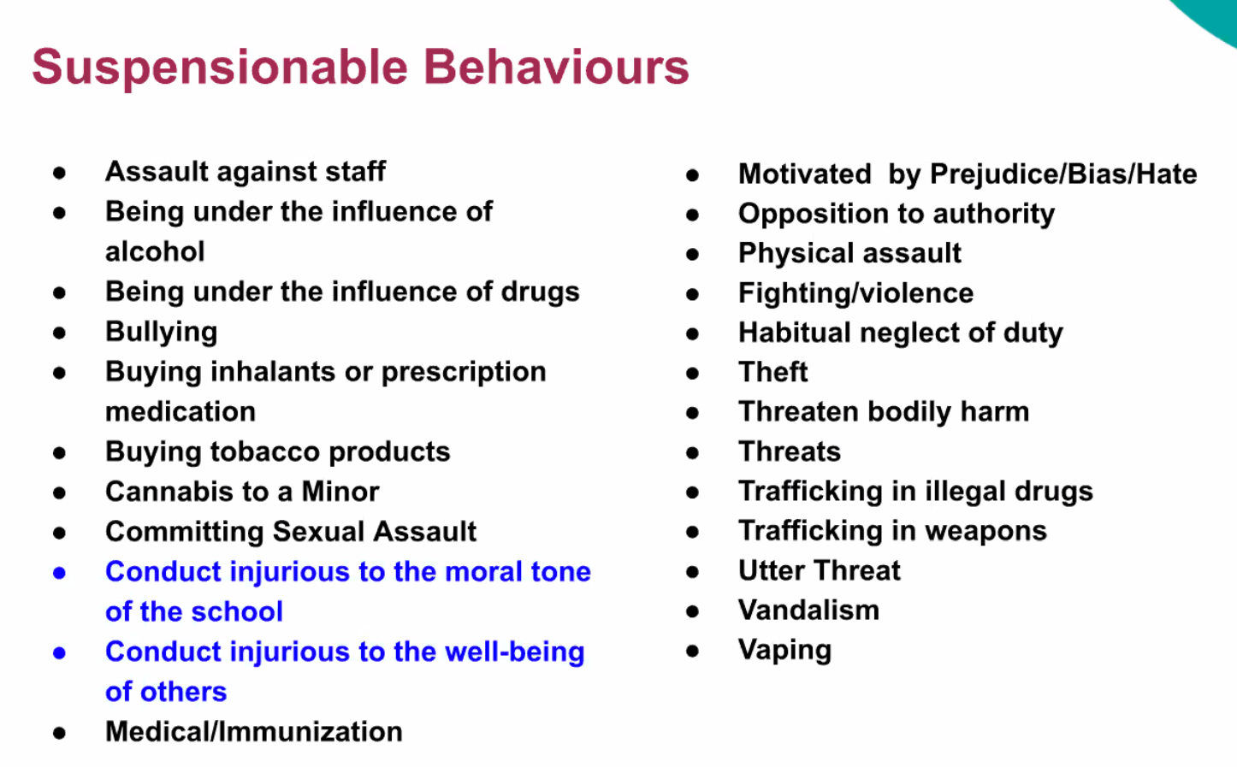  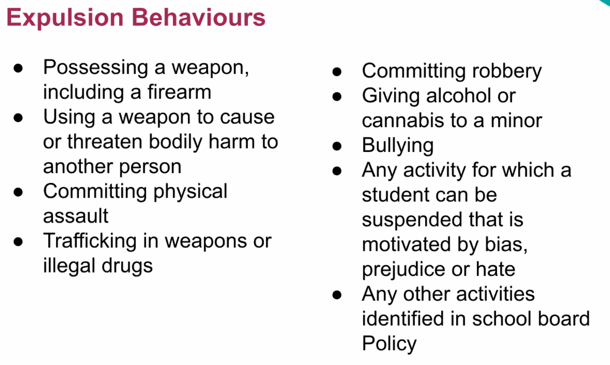  Reaching a decision for an expulsion: Prior  -meet with the student and with the parent/guardian, student that is at least 18 yrs old or is 16 or 17 yr old and has withdrawn from parental authority, or adult student to review and provide an account of the incident.  -meet with any witnesses to obtain statements  -review the students Ontario student record  -consider the students individual education Plan  -….  Mitigating factors  Student does not have the ability to control his or her behavior.  Student does not have the ability to understand the foreseeable consequences.  Other factors….  OCIP: Ottawa Catholic Intervention Program
Nov 11, 2021 | Diversity, Equity & Inclusion In the Classroom: Addressing Recial and Cultural Needs | Janelle Abela |  | 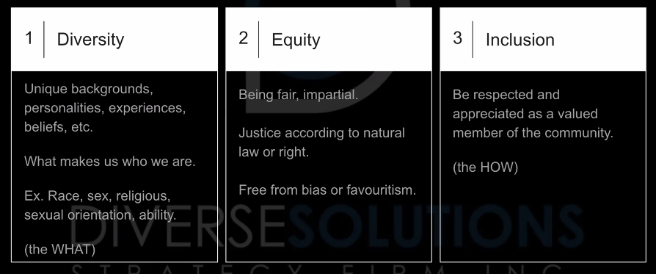  Discriminatory language: oral or written communication that can cause misunderstandings and/or pain in personal and professional settings  Gender Discrimination: Using expressions that render women invisible and discriminate them.  - Good: “Take charge of” “Best person for the job”  Student Voice:  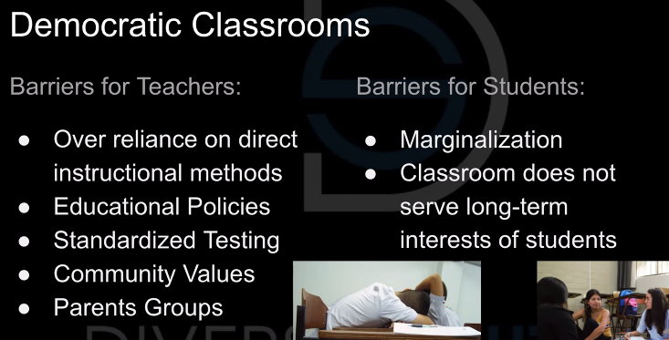  Implementing Discussion Pedagogy:  - Select meaningful texts  - Construct central questions that guide students’ inquiry and serve as a point for the open forum of discussion.  Anti-Oppressive Practices:  - Create a safe space – welcome all ideas, agreements, and disagreements 9What else?)  - Embrace marginalized voices – strategically facilitate differing opinions (let everyone speak)  - Allow everyone to be heard – change up discussion methods (discussions in large group, small groups, individual through journaling, one-to-one)
Nov 11, 2021 | Nurtured Heart Approach | Carolyn McGuire,  Karen Hill |  | There has been an intense shift in extremem behaviours. Ex: flight risks, anger.  https://heartliftingsolutions.com/  Learning Crossroads  Nurturing Heart Approach: Give educators and parent the tools to help kids be successful especially during challenging times.  - 8:1 ratio. 8 successes 1 challenge. Find ways to show that a student is experiencing success when misbehaving because it is hard to recognize it when you are acting out.  Students will misbehave when they feel threatened.  Stating when you do something good too. “wow, I just took a deep breath. I almost started yelling because the noise level was so loud. I am such a re-setter” Modeling for the students.  - “I want to tell you something. You have a gift. You feel so intensely and that is so great. It is such a rare gift. So rare that a lot of adults may never understand it. I don’t understand it. Sometimes it might be destructive and may even break some relationships. Don’t ever feel ashamed of this gift. We need to learn how to harness this intensity and learn how to use it to make a big difference.”  Upside down energy/connection: the students get the attention at the wrong time. When they are misbehaving. NHA works to make this attention/connection rightside up.  Blurting out: wow, I love how eager you are to participate in my lesson. Paying attention! Hold that thought. I want to hear the people who have their hands up. I am excited to hear what they have to say!  Humorous blurting: wow Jim, let me tell you what I see. I see you being paying attention to my class. So much that you know exactly when to make a joke. It takes a lot of intelligence to be able to do that. Let’s work on how to use that better. Hannah, I noticed that you didn’t laugh. Thank you, that helps Jim’s brain a lot. Who else didn’t laugh? Who did laugh?  Joke: Oh, I didn’t get it. Do you want to explain it to me so that I can? “no, I am just being silly” look at you being so mature to recognize when you just being silly. That is a leadership quality.  The stands:  - No energy to the negative (misbehaving). Don’t ignore the positive.  - I am going to pay way more attention when you are doing the things I do want more.  - Really clear rules and simple consequences.
November 25, 2021 | Resumes and Interviews | Linda Mosley |  | - Add your references on your resume. It will be thrown out otherwise. “they don’t have time to contact you again”  - Highschool education not required
Dec 9, 2021 | Bullying and being a leader | Dr. Eva Olsson | The story of a holocaust survivor. How it is important to stand up for bullies and to be a leader. | - March 14, 1994, Germany invaded Hungary (Dr. Eva Olsson’s home). March 15, the Hungarians marched to the cattle cars. Dr. Olsson rode on her train of ~100 people for 4 days with only 2 pails. 1 for water, 1 for the toilet. The water did not last long.  - Arrive at Auschwitz and separated from her family. Her sister was the only one directed to the same side as Eva.  - Her father did not stay at Auschwitz. He was taken to another facility where he lasted only 6 months. A very healthy and educated man, who exercised regularly.  - The day Eva and her sister were to get their numbers tattooed, businessmen and officials showed up to take about 2500 women as slave workers. Therefore, she did not get her tattoo.  - They were brought to a factory, which was already bombed. About 150 women stayed in a hole under the kitchen because it was the only building left standing. They slept on straw. They could not leave at night to use the bathroom because they were too scared, so they had to use the floor that they slept on. During the day, they worked in the factory, moving bricks off trucks or other factory work. They were there for 4 months  - The allies were approaching, so they heard rumors that they were being moved. Eva and her sister were moved to Bergen Belsen, the camp where Anne Frank died.  - It was built to be a barrack but turned into a camp. This is where everyone got “diaper” fever. Eva got it before her sister, which kept her living because she knew she had to stay alive to take care of her sister. Everyone was too weak to get up to leave for the bathroom, so again, the floor that they slept on was covered in Diarrhea.  - Word of allies approaching caught wind and so the Nazi’s had planned on gassing Eva’s group on liberation day at 3:00. The allies came around 11:00. Her sister was in the hospital for 2 months after this day.  - The red cross gave everyone the option to choose what they did. They could go to Sweden, Switzerland, Hungary, Canada, etc. It would be covered. Eva chose to go to Sweden where she embraced the Swedish culture. There, there it was ok to be different but there was trouble if you were indifferent.
Jan 26, 2022 | OMEA Interview Workshop | Katie Nicholl |  | Kevin Merkley:  - Dress for it: Know the job and dress for it. Ex: if you are applying for a primary job and show up in a suit, you may not be sending the message you intend. Demonstrate that you are ready for the job.  - 6 Questions/5 mins: you will have 30 minutes to share your passion for education, your subject knowledge, and examples of how you work with your students in the classroom. Most school boards will ask questions that will focus on literacy, numeracy, collaboration, assessment, equity and inclusive education, and possibly about how you would manage a challenging student.  - Practice!  - Conclusion. Figure out how to wrap up each question  - Root theory in practice: connect theory to practice. Use every second by taking the time to illustrate what you would do in the classroom to support student achievement and well-being.  - After your interview: Send a follow-up email thanking the principal for the opportunity and highlight what you noticed about the school or learned through the interview. Then, ask for feedback! Take the feedback in stride and use what you think will be helpful to you based upon your own reflection of the experience to help you grow.  How do you meet the needs of all your students to give them the best experience in your class?  Know your students so you can give them the differentiated instruction they need. Ability pairing with seating. Well-being and safety, they are not going to care to learn until they learn that you care. Do students see themselves reflected in their learning? Value pronunciation of names. Pick up the little interactions, who participates and who doesn’t.  What do you expect to achieve as a music teacher?  That my students come back to my class wanting to learn more from me. Try and get the students to learn to love music in what ever way that is important to them. To create a safe space where students feel welcomed and are safe to take risks. To create a space where they belong.  How is technology incorporated in your classroom?  A way to show off your classroom! A way to connect with the community/build community. (WEVIDEO) Make sure not to talk over your principal’s head – don’t get carried away.  Describe a time when collaboration was a challenge. What did you do?  Scheduling intramurals during festival season. What until you are calm and have a private conversation. Respect other people’s programs. Watch basketball games, etc.  How does your work in music promote and support literacy and numeracy?  Always try and pull something out that is not music. Centuries:cent=hundred. Not just being a music teacher, but a “problem solving teaching”  How do you incorporate equity into your practice?  Secondary: make reference to the growing success document!  How do you cope with stress?

*The description may be copied from the outline in the posting for this event.

